**Lab Exercise 3– Volume in Docker**

**Steps to Complete:**

1. View all Volume in Docker

**Command : docker volume ls**

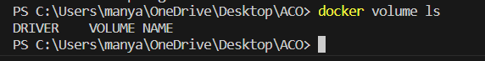

1. Create a new Volume

**Command: docker volume create myvol2**

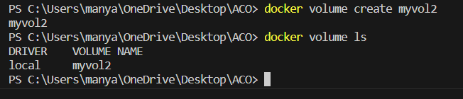

1. Mount a Volume with a container

**Command: docker run -it -v myvol2:/data redis /bin/bash**

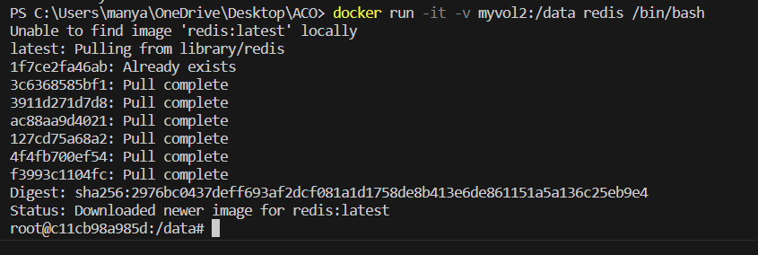

1. Create another container and Mount with the same Volume

**Command: docker run -it -v myvol2:/data redis /bin/bash**

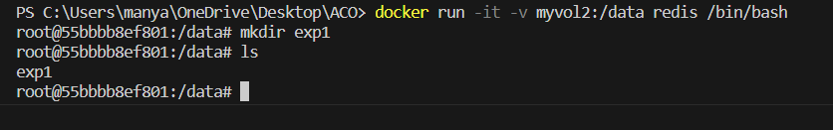

1. See the complete working of container
2. Exited from container and restart again to see the persistent of Docker Volume

C:\Users\Administrator>docker start 0a4c04d42a96

C:\Users\Administrator>docker attach 0a4c04d42a96

root@0a4c04d42a96:/data# ls

abc.txt test

root@0a4c04d42a96:/data#